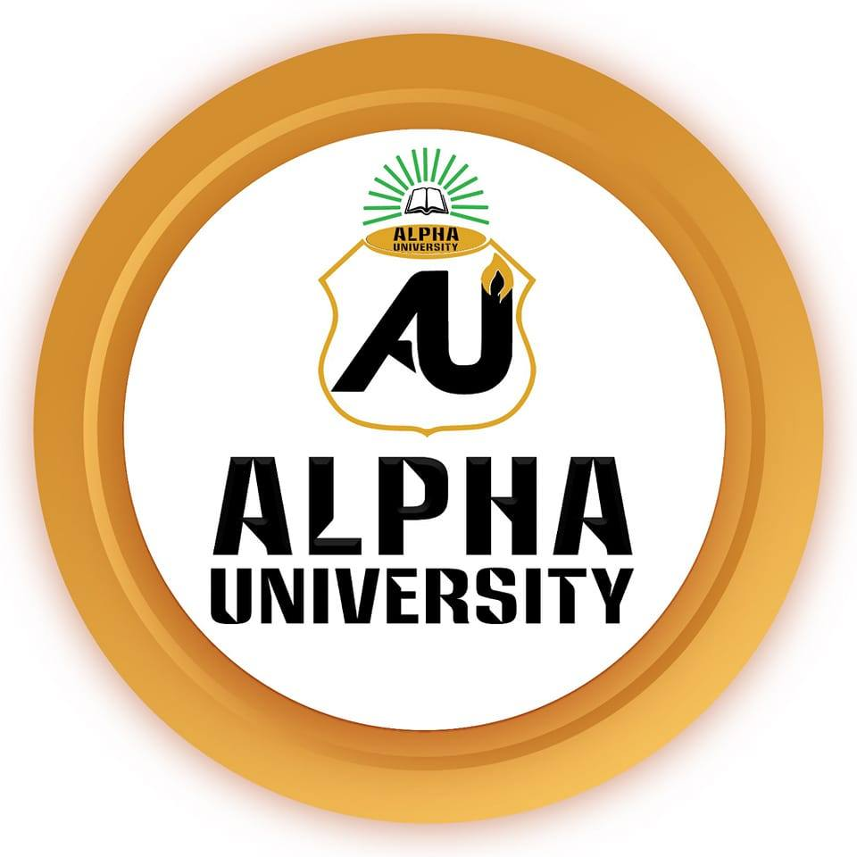

**BRIDGING THE CHASM: ENHANCING GRADUATE EMPLOYABILITY IN SOMALIA THROUGH STRATEGIC TRAINING AND DEVELOPMENT**

**BY**

**ABDIKADIR ABDULLAHI HUSSEIN**

**STUDENT ID: LU202502260002**

**COURSE NAME: HUMAN RESOURCE MANAGEMENT**

**PROGRAM: MBA IN PROJECT MANAGEMENT**

**ALPHA UNIVERSITY & LINCOLN UNIVERSITY**

**SUBMISSION DATE: MAY 31, 2025**

**Table of Contents**

1. Introduction 2

1.1. Somalia's Socio-Economic Context and Human Capital 2

1.2. The Role of University Graduates 2

1.3. Thesis Statement 2

2. Graduate Unemployment and Skills Mismatch in Somalia 2

2.1. Statistical Overview 2

2.2. The Skills Gap Challenge 3

2.3. Consequences of Skills Gap and Unemployment 3

3. Current Training and Development Ecosystem in Somalia 4

3.1. Overview of T&D Providers and Programs 4

3.2. HRM Practices and T&D Emphasis 4

3.3. Challenges in the T&D Sector 4

4. Theoretical Underpinnings for Effective T&D in a Fragile Context 5

4.1. Relevant Development Theories 5

4.2. Adaptable T&D Models 5

4.3. Adult Learning Principles (Andragogy) in Somalia 6

4.4. Conflict-Sensitive and Contextualized T&D 6

5. Strategies for Enhancing T&D Initiatives for Somali Graduates 6

5.1. Aligning T&D with Labor Market Demands 6

5.2. Innovative and Accessible T&D Delivery 6

5.3. Capacity Building for T&D Providers and HRM Professionals 7

5.4. Policy Recommendations for Coordinated Action 7

6. Monitoring and Evaluation (M&E) of T&D Interventions 7

6.1. Applying Evaluation Frameworks 7

6.2. The Role of Tracer Studies 8

6.3. Feedback Mechanisms for Improvement 8

7. Conclusion & Recommendations 8

7.1. Recapitulation of Key Findings 8

7.2. Imperative for Collaborative T&D Investment 8

7.3. Call to Action 8

8. References 9

# 1. Introduction

## 1.1. Somalia's Socio-Economic Context and Human Capital

Somalia's socio-economic landscape has been profoundly shaped by decades of instability following the collapse of its central government in 1991 (ACAPS, 2025). This enduring fragility has severely impacted institutional capacity, economic structures, and human capital development. Persistent clan conflicts further disrupt essential services like education and limit opportunities, creating a challenging environment for developmental initiatives (ACAPS, 2025). The direct impact on the education system includes compromised quality and relevance, contributing to high youth unemployment and hindering sustainable economic growth (Alin, 2025). This protracted conflict and weak governance erode educational institutions' ability to provide market-relevant education, meaning the skills gap among graduates is a symptom of deeper systemic failures (Mohamed, 2024). Effective Training and Development (T&D) must therefore be conflict-sensitive and address more than technical skills, considering the psychological impact of conflict and the breakdown of social capital (Samuel Hall, 2016).

## 1.2. The Role of University Graduates

Despite these challenges, higher education is increasingly seen as pivotal for Somalia's economic revival and national reconstruction (Yusuf & Abdulle, 2020). University graduates represent vital human capital, essential for rebuilding institutions, fostering innovation, and driving socio-economic progress. However, a paradox exists: high graduate unemployment coexists with a need for skilled professionals (Isse et al., 2022). This underscores the severity of the skills mismatch and the urgent need for interventions to bridge this gap.

## 1.3. Thesis Statement

This report argues that targeted, contextualized, and collaboratively driven Training and Development initiatives are essential to bridge the significant skills gap among Somali university graduates. Such initiatives are paramount for enhancing their employment outcomes and enabling them to contribute meaningfully to Somalia's sustainable development and peacebuilding efforts.

# 2. Graduate Unemployment and Skills Mismatch in Somalia

## 2.1. Statistical Overview

Unemployment among Somali youth, particularly university graduates, is acute. Youth unemployment reaches 67% (Alin, 2025), and 62.9% of university graduates are unemployed (Isse et al., 2022). World Bank (2021) data shows high youth labor underutilization (55.1%) and youth inactivity (84.2%) in 2021. Gender disparities are notable, with female youth unemployment (40.8%) higher than male (35.2%), and male graduates being 1.47 times more likely to find employment (Isse et al., 2022). A significant number of graduates remain unemployed for over five years (Ahmed, 2025), fostering disillusionment.

*Table 1: Key Youth and Graduate Unemployment Indicators in Somalia (2019-2021)*

|  |  |  |
| --- | --- | --- |
| **Indicator** | **Value** | **Source(s)** |
| Youth Unemployment Rate (15-35 years) | 67% | Alin (2025) |
| University Graduate Unemployment Rate | 62.9% | Isse et al. (2022) |
| Youth Labor Underutilization Rate (15-24 yrs) | 55.1% | World Bank (2021) |
| Youth Inactivity Rate (15-24 yrs) | 84.2% | World Bank (2021) |

## 2.2. The Skills Gap Challenge

High graduate unemployment is linked to a significant skills gap, driven by a mismatch between higher education curricula and labor market demands (Yusuf & Abdulle, 2020; eCampus News, 2025). This reflects a systemic disconnect between education providers, employers, and policymakers, hindered by weak labor market information systems (LMIAS) (MoLSA, n.d.).

Specific deficiencies include:

* Technical Skills: Gaps exist in areas like project management and specialized engineering, particularly in emerging sectors like renewable energy (One Earth Future, 2022). The AfDB's SEIP project aims to address this through demand-driven TVET (GCA, n.d.).
* Soft Skills: Graduates often lack CV writing, interviewing, problem-solving, and communication skills (Alin, 2025; SomaliJobs, 2024).
* Practical Experience: A lack of real-world learning and on-the-job training is common (eCampus News, 2025), with part-time experience significantly enhancing employability (Isse et al., 2022).

Employer perspectives confirm this mismatch (Baraarug Forum, 2025; One Earth Future, 2022). This issue is prevalent across Sub-Saharan Africa (AfDB, 2019).

## 2.3. Consequences of Skills Gap and Unemployment

The ramifications are detrimental:

* For Graduates: Prolonged unemployment leads to frustration and negative attitudes towards education (Ahmed, 2025), potentially contributing to brain drain (Isse et al., 2022).
* For the Somali Economy: Loss of productive potential and reliance on foreign expertise hinder indigenous growth and innovation (One Earth Future, 2022; Mohamed, 2024).
* For Social Stability: High youth unemployment can be destabilizing (Mohamed, 2024). Effective T&D leading to employment can be a peacebuilding tool (Samuel Hall, 2016).

# 3. Current Training and Development Ecosystem in Somalia

## 3.1. Overview of T&D Providers and Programs

The T&D landscape involves private entities (e.g., African Academy For Professionals (SomaliJobs, 2024)), public institutions (e.g., Ministry of Finance (Human Resources & Training Dept., 2025), MoLSA (GCA, n.d.), School of Management and Public Administration (CCNET, 2025)), and NGOs/international partners. Key international initiatives include the AfDB's SEIP project (GCA, n.d.), UNFPA's Dalbile Youth Initiative (ILO, 2016a), ILO programs (ILO, 2016b), UNICEF's Youth Education Pack (YEP) (Samuel Hall, 2016), and World Bank projects (World Bank, 2025a; World Bank, n.d.). Programs focus on HRM, technical/vocational skills, soft skills, entrepreneurship, and public sector capacity building. For instance, Dalbile reached 1,569 youth, funding 68 start-ups in its first year (ILO, 2016a), while YEP graduates report 22-60% gaining regular income (Samuel Hall, 2016).

## 3.2. HRM Practices and T&D Emphasis

HRM is gaining recognition in Somali organizations, with T&D acknowledged as a core function for enhancing proficiency and performance (Dahir & Ali, 2021). Studies show an emphasis on T&D, recruitment, and compensation, though areas like performance management may be less developed (Dahir & Ali, 2021). The nascent state of formal HRM systems, hampered by resource constraints, cultural norms, and weak legal frameworks, impacts T&D effectiveness (Shire, 2024). While some firms like Hormuud Telecom link HRM practices (including T&D) to performance (Yusuf & Guled, 2017), systemic weaknesses mean T&D programs may not achieve their full potential without broader HRM capacity building.

## 3.3. Challenges in the T&D Sector

The T&D sector faces several challenges:

* Resource Constraints: Lack of funds, technology, and qualified professionals limit T&D provision (Yusuf & Abdulle, 2020; Baraarug Forum, 2025).
* Lack of Coordination: Fragmented TVET systems suffer from unharmonized curricula and inconsistent quality assurance (GCA, n.d.).
* Quality and Relevance: Ensuring programs are high quality, market-relevant, and lead to employment is a persistent issue (One Earth Future, 2022; Samuel Hall, 2016).
* Data Deficiencies: Absence of comprehensive labor market data restricts evidence-based program design (MoLSA, n.d.).
* Security and Accessibility: Insecurity can disrupt T&D and limit access, especially in remote areas (ACAPS, 2025).
* Sustainability: Heavy reliance on donor funding raises concerns about long-term viability (Baraarug Forum, 2025).

# 4. Theoretical Underpinnings for Effective T&D in a Fragile Context

## 4.1. Relevant Development Theories

Modernisation Theory (Rostow) suggests T&D should focus on skills for industrialization and modern sector employment (Internet Geography, 2025). Dependency Theory (Frank) argues T&D should aim to break dependency cycles by fostering indigenous innovation and self-reliance (Internet Geography, 2025). A pragmatic Somali T&D strategy should synthesize elements, aiming to equip graduates with skills for economic "take-off" (Investopedia, 2024) while promoting local ownership, contextual relevance, and indigenous solutions, fostering critical thinking and local problem-solving (Baraarug Forum, 2025; Alin, 2025).

## 4.2. Adaptable T&D Models

* ADDIE Model (Analysis, Design, Development, Implementation, Evaluation): Its structured process (DevlinPeck, n.d.) is beneficial, but the 'Analysis' phase needs deep contextualization for Somalia’s resource limits and conflict dynamics. Implementation requires flexibility. An iterative approach (e.g., SAM model) with rapid prototyping is advisable.
* 70:20:10 Model (Experiential, Social, Formal Learning): Highly relevant for Somalia (Risely, 2024), promoting apprenticeships and mentorship. Challenges include finding suitable workplaces for the '70%' and structured mentorship for the '20%'. Partnering with resilient local businesses and virtual mentorship can help.
* Kirkpatrick's Four-Level Evaluation Model (Reaction, Learning, Behavior, Results): Essential for impact measurement (Risely, 2024). Assessing Level 3 (Behavior) and 4 (Results) is challenging in unstable environments. Adaptations include qualitative indicators and focusing on short-term changes and employment uptake.
* Theory of Change (ToC): Crucial for mapping causal pathways to employment in complex environments (Sopact, n.d.). Flexible ToCs with explicit "fragility assumptions" and regular reviews are needed.

## 4.3. Adult Learning Principles (Andragogy) in Somalia

Knowles' principles (adults are self-directed, experienced, problem-centered, internally motivated) (Knowles, 1984, as cited in Mohamed, 2024) imply T&D should be practical and problem-based. In Somalia, application must navigate varied educational backgrounds, conflict disruptions, and trauma (Samuel Hall, 2016). Creating a psychologically safe, supportive learning environment is paramount, integrating Mental Health and Psychosocial Support (MHPSS) principles where appropriate (Alliance for Child Protection in Humanitarian Action, n.d.). Content must offer tangible benefits to overcome anxieties and "fear of adult learning."

## 4.4. Conflict-Sensitive and Contextualized T&D

All T&D must be conflict-sensitive, aiming to "do no harm" and, where possible, contribute to peacebuilding (Samuel Hall, 2016). This requires understanding local conflict dynamics and ensuring equitable service delivery. Contextualization—adapting content, methods, and structures to Somali cultural norms, community needs, and resource availability—is critical, especially for life skills and MHPSS components (Alliance for Child Protection in Humanitarian Action, n.d.; World Bank, 2025a).

# 5. Strategies for Enhancing T&D Initiatives for Somali Graduates

## 5.1. Aligning T&D with Labor Market Demands

Effective T&D must align with labor market needs through:

* Strengthening University-Industry-Government Linkages: Foster tripartite collaborations for curriculum co-creation, internships, and feedback loops (GCA, n.d.).
* Integrating In-Demand Skills: Prioritize technical skills for growth sectors (e.g., renewable energy (One Earth Future, 2022), ICT, climate-smart agribusiness), essential soft skills (Alin, 2025; ILO, 2016a), and entrepreneurial skills (Alin, 2025).
* Leveraging LMIAS: Support a national LMIAS for real-time data on skills demand and supply (MoLSA, n.d.).

## 5.2. Innovative and Accessible T&D Delivery

Enhance reach and effectiveness through:

* Technology-Enabled Learning: Utilize online platforms and mobile learning for accessibility and flexibility (Sopact, n.d.; IMF, 2023).
* Work-Integrated Learning (WIL): Expand apprenticeships and internships (Isse et al., 2022; eCampus News, 2025).
* Mentorship and Coaching Programs: Establish programs for knowledge transfer and career guidance (eCampus News, 2025).
* Micro-credentials: Offer short, targeted modules for specific skills, allowing flexible, stackable qualifications (eCampus News, 2025).

## 5.3. **Capacity** Building for T&D Providers and HRM Professionals

Enhance the quality of T&D delivery by:

* Training of Trainers (ToT): Invest in programs for instructors in pedagogical, technical, and industry-relevant skills (GCA, n.d.).
* Professionalizing HRM: Support HR development through certifications (SomaliJobs, 2024) and continuous professional development in strategic T&D.
* Strengthening Institutional Capacity: Bolster government bodies, educational institutions, and NGOs to plan, manage, and monitor T&D programs (GCA, n.d.).

## 5.4. Policy Recommendations for Coordinated Action

A coherent, multi-stakeholder T&D policy framework is crucial. This requires:

* Government: Develop a national T&D strategy aligned with economic plans, allocate sustainable budgets (CCNET, 2025), establish quality assurance, incentivize employer participation, and strengthen HRM legal frameworks (Shire, 2024).
* Educational Institutions: Regularly update curricula with industry consultation, integrate practical learning and soft skills, foster industry partnerships, and strengthen career services (Yusuf & Abdulle, 2020).
* Employers/Private Sector: Participate in T&D design, offer internships and on-the-job training, articulate skill needs, and invest in workforce upskilling.
* International Partners: Provide financial/technical support aligned with national priorities, promote local ownership, build sustainable local capacity, and support M&E systems (IMF, 2023).

# 6. Monitoring and Evaluation (M&E) of T&D Interventions

Effective M&E is vital for ensuring T&D interventions achieve objectives and adapt to the Somali context.

## 6.1. Applying Evaluation Frameworks

* Kirkpatrick's Model: Evaluate programs at Reaction, Learning, Behavior, and Results levels (Risely, 2024). In Somalia, Levels 3 and 4 require a pragmatic mix of quantitative (employment rates, income changes) and qualitative methods (case studies, employer feedback), acknowledging attribution challenges.
* Theory of Change-Based Evaluation: Assess if outcomes are achieved along hypothesized causal pathways, providing insights into program efficacy (Sopact, n.d.).

## 6.2. The Role of Tracer Studies

Regular tracer studies of graduates are invaluable for tracking employment status, career progression, skills relevance, and labor market challenges (Tadesse & White, 2018). Findings inform curriculum reviews, program design, and policy adjustments.

## 6.3. Feedback Mechanisms for Improvement

M&E in fragile contexts like Somalia (World Bank, 2025a) must be adaptive and learning-oriented. This involves frequent data collection (quantitative and qualitative), regular reflection points, and robust feedback channels from all stakeholders. This allows for near real-time adjustments, using M&E as a tool for ongoing program improvement rather than solely for final judgment (Sopact, n.d.).

# 7. Conclusion & Recommendations

## 7.1. Recapitulation of Key Findings

This report highlighted widespread skills gaps and high graduate unemployment in Somalia, intertwined with national fragility. While numerous T&D initiatives exist, effectiveness is often hampered by resource constraints and lack of coordination. However, contextualized, conflict-sensitive T&D programs hold significant potential.

## 7.2. Imperative for Collaborative T&D Investment

Addressing graduate employability requires concerted, strategic, and sustained T&D investment from all stakeholders. This is vital for Somalia's peacebuilding, social cohesion, and sustainable development, empowering graduates to become active agents in national reconstruction.

## 7.3. Call to Action

1. Foster a National Dialogue and Coordinated Strategy: Develop a unified national skills development strategy integrating inputs from education, private sector, and civil society.
2. Prioritize Labor Market Intelligence: Invest in a robust LMIAS to guide curriculum and T&D program design.
3. Strengthen Educational and T&D Institutions: Build capacity in curriculum design, pedagogy, quality assurance, and employer linkages.
4. Incentivize Private Sector Engagement: Encourage employer investment in internships, apprenticeships, and collaborative T&D.
5. Embed Conflict Sensitivity and Contextualization: Design and implement all T&D through a conflict-sensitive, culturally appropriate, and inclusive lens.
6. Promote Entrepreneurship and Innovation: Support graduate-led start-ups for job creation and economic diversification.
7. Commit to Adaptive M&E: Implement flexible, learning-oriented M&E for continuous program improvement.

By embracing these imperatives, Somalia can bridge the skills chasm, unlock graduate potential, and pave the way for a prosperous, stable future.

# 8. References

ACAPS. (2025, March 19). Crisis Impact of clan conflicts in Somalia. ACAPS.

African Development Bank Group. (2019). Youth Jobs, Skill and Educational Mismatches in Africa (Working Paper No. 326).

Ahmed, A. M. (2025). The impact of unemployment on the university graduates’ attitude towards education in Mogadishu-Somalia. International Journal of Trend in Scientific Research and Development, 9(1), 232-241.

Alin, A. H. (2025, February 1). Youth Unemployment and Empowerment in Somalia. Daily News Egypt.

Alliance for Child Protection in Humanitarian Action. (n.d.). Contextualization Guidance: MHPSS in CAAFAG Programmes Operational Guidance.

Baraarug Forum. (2025, May 27). Lack of Local Innovation and Skills Linked to Youth and Women Unemployment in Somalia. Horn Observer.

CCNET. (2025). The Contribution of Training and Development to Employee Performance and Public Service Delivery in the Federal Government of Somalia. International Journal of Business and Management.

Dahir, A. M., & Ali, A. Y. S. (2021). A Factor Analysis of Human Resource Management Practices in Telecommunication Companies in Somaliland. Novelty Journals.

DevlinPeck. (n.d.). ADDIE Instructional Design. Retrieved from <https://www.devlinpeck.com/content/addie-instructional-design>

eCampus News. (2025, May 28). Bridging the skills gap: How universities can align curricula with workforce needs. eCampus News.

Global Center on Adaptation. (n.d.). Call for Partnership Support to the AfDB Somalia – Skills For Employability, Inclusion and Productivity (SEIP) Project. GCA.

Human Resources & Training Department, Ministry of Finance Somalia. (2025). Human Resources & Training. Retrieved from <https://mof.gov.so/department/human-resources-training>

International Labour Organization. (2016a, January). The ILO in Somalia. ILO. [Note: This was attributed as source 4 for Dalbile previously, a more direct source for Dalbile if available would be better, but using provided attribution]

International Labour Organization. (2016b). The ILO in Somalia. ILO. [Note: This was attributed as source 19 for general ILO programs]

International Monetary Fund. (2023, September 21). Fragile States Need Customized Support to Strengthen Institutions. IMF Blog.

Internet Geography. (2025, May 31). How Do Development Theories Explain Development? Retrieved from <https://www.internetgeography.net/edexcel-b-gcse-geography-revision/how-do-development-theories-explain-development/>

Investopedia. (2024, June 30). How Education and Training Affect the Economy. Retrieved from <https://www.investopedia.com/articles/economics/09/education-training-advantages.asp>

Isse, M. M., Abdulle, M. M., & Mohamud, A. O. (2022). Modelling the Determinants of Unemployment Exit Duration among Graduates in a Fragile State: A Case of Somalia. Journal of Economics and Sustainable Development.

Knowles, M. S. (1984). Andragogy in Action: Applying Modern Principles of Adult Learning. Jossey-Bass.

Ministry of Labour and Social Affairs (MoLSA) Somalia. (n.d.). LMIAS. NESC.

Mohamed, A. M. (2024, August 15). Educational Challenges in Post-Conflict Somalia: A Comprehensive Review. International Journal of Education, Culture and Society.

One Earth Future. (2022, July). Somali Renewable Energy Skilled Workforce Survey Report.

Risely. (2024, November 11). 6 Learning and Development Models For Employee Growth. Retrieved from <https://www.risely.me/learning-and-development-models/>

Samuel Hall. (2016, September 26). Evaluation of the Youth Education Pack (YEP) Programme in Somalia. UNICEF/ALNAP.

Shire, A. M. (2024). Investigating the Role of Human Resources in Somali Organizations: Enhancing HR Practices for Sustainable Development in Post-Civil War Somalia. Zenodo.

SomaliJobs. (2024). Training: Human Resources Management - (Online) African Academy For Professionals. Retrieved from [https://somalijobs.com/courses/hargeisa/2304493920369566/training:-human-resources-management-(online](https://somalijobs.com/courses/hargeisa/2304493920369566/training:-human-resources-management-(online))

Sopact. (n.d.). The Core Role of Theory of Change in Workforce Development. Retrieved from <https://www.sopact.com/guides/workforce-development-programs>

Tadesse, S., & White, H. (2018). TVET Graduate Tracer Study in Somaliland. ReliefWeb.

World Bank. (2021). Human Capital Index 2020 Update: Somalia. World Bank.

World Bank. (2025a, April 14). Delivering Education in the Midst of Fragility, Conflict, and Violence. World Bank Brief.

World Bank. (n.d.). Somalia Enhancing Public Resource Management Project. Retrieved from World Bank Projects & Operations.

Yusuf, M. A., & Abdulle, A. M. (2020). The Role of Higher Education in Rebuilding Somalia’s Economy: Impacts on Labor Capacity, Governance, and Entrepreneurship. International Journal of Social Sciences and Regional Planning (IJSSRR).

Yusuf, M., & Guled, A. (2017). Human Resource Management Practice and Organizational Performance: Case Study at Hormuud Telecom in Mogadishu-Somalia. European Researcher. Series A.